# Laboratory 5

Title of the Laboratory Exercise: Java database programming

1. **Introduction and Purpose of Experiment**

The SQL includes commands to define view on the data. A view contains rows and columns, just like a real table. Java uses JDBC (Java Database Connectivity) to connect to databases. JDBC allows to connect to a wide-range of databases such as Oracle, MySQL, etc. By doing this lab, students will be able to implement views in SQL and connect the developed database with the application.

1. **Aim and Objectives**

Aim

* To design and implement views on the data using SQL commands
* To connect to the relational database in Java

Objectives

At the end of this lab, the student will be able to

* Design and execute views using SQL commands
* Perform database programming in Java

1. **Experimental Procedure**
   * 1. Analyse the problem statement
     2. Execute the built-in functions in SQL
     3. Design and execute the view statements in SQL
     4. Test the executed commands
     5. Document the Results
     6. Analyse and discuss the outcomes of your experiment
2. **Questions**
   1. Write a Java program to do the following operations
3. Insert the details of the Managers into the table
4. Display all the details of the Managers in the ascending order of their names
5. Count the number of Managers staying in each location and display the address and the total number
6. Display the number of Managers in each location. Only include locations with more than 3 Manager ssle
7. **Presentation of Results**

**Java Program**

**Main**

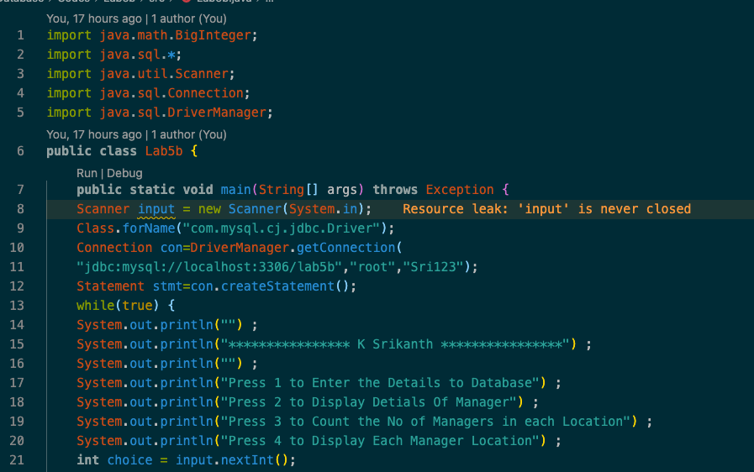

Figure 1 Java Program with JDBC Connection and MENU

**Choice 1**

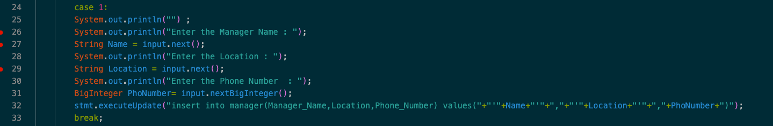

Figure 2 Java Program to take user input for database using JDBC

**Choice 2**

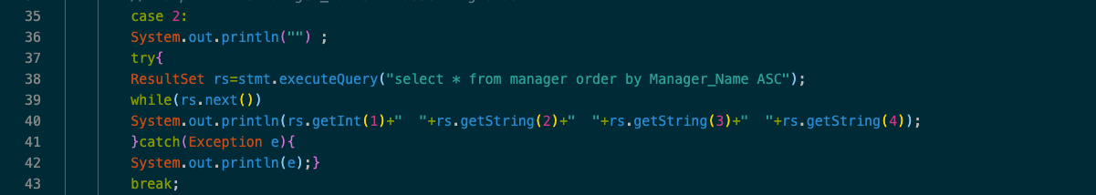

Figure 3 Java Program to display all the Manager Name in Ascending order using JDBC

**Choice 3**

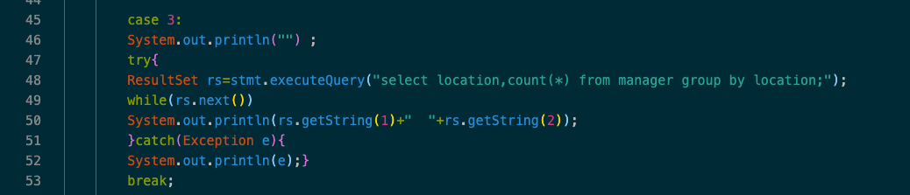

Figure 4 Java Program to count the number of managers in each location using JDBC

**Choice 4**

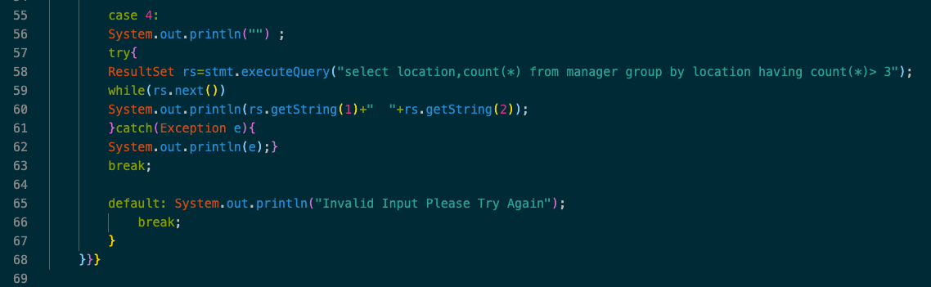

Figure Java Program to count the number of managers in each location greater than 3 using JDBC

**Result / Output**

**Menu**

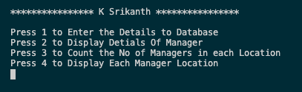

Figure 6 Java Program output switch case menu choice

**Choice 1**

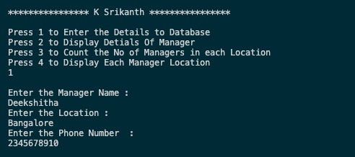

Figure 7 Java Program output for choice 1

**Choice 2**

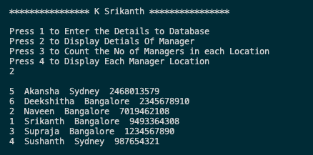

Figure 8 Java Program output for choice 2

**Choice 3**

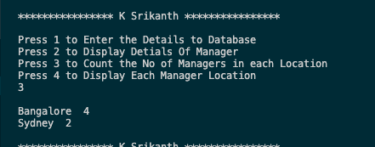

Figure 9 Java Program output for choice 3

**Choice 4**

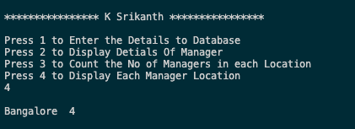

Figure 10 Java Program output for choice 4

1. **Analysis and Discussions**

JDBC offers a programming-level interface that handles the mechanics of Java applications

communicating with a database or RDBMS. The JDBC API supports communication between the

Java application and the JDBC manager. Import MySQL Library using *import java.sql.*;*

Under Main Function for connecting to MySQL database

***Class.forName("com.mysql.cj.jdbc.Driver");***

***Connection con=DriverManager.getConnection(***

***"jdbc:mysql://localhost:3306/databaseName","UserName","Password");***

Now that our database is connected with our application to perform database queries we create a statement object with the help of connection object to write queries using statement object

***Statement stmt=con.createStatement();***

Using stmt we can now start writing queries using executeupdate

***stmt.executeUpdate("SQL Qurery HERE ")***

Using a while loop we can print the result for the queries.

1. **Conclusions**

JDBC driver is used to make SQL queries. JDBC provides an interface to make SQL queries in java program.

1. **Comments**

**1. Learning happened**

Learned to connect MySQL database with java project using JDBC